Example error: Contrast

Regular text
This regular sized text is under the 4.5:1 at 3:1 contrast ratio #5692FF.
A11y automated checker | Microsoft Accessibility checker
Detected | Detected

Large text
This large sized text is under 3:1 contrast ratio at 2:1 #91BFE1.
A11y automated checker | Microsoft Accessibility checker
Detected | Detected

Graphic element
This line chart has graphic elements under 3:1. #F1B4A4 is 1.8:1.

A11y automated checker | Microsoft Accessibility checker
Not detected | Not detected

Color used as sole means of communication
Differentiation between undergrad and grad relies on color alone barring access to people with color vision deficiency. The green and red are nearly indistinguishable in grayscale which simulates achromatopsia color vision deficiency. This testing feature is available in PowerPoint, but not Word.
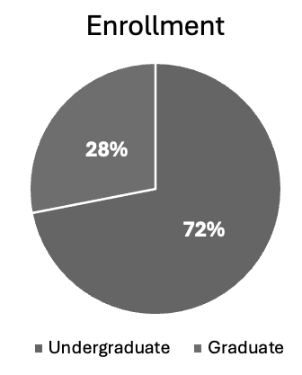
A11y automated checker | Microsoft Accessibility checker
Not detected | Not detected

